Project 2: Software System for Engineering Joint Seat Allocation

UCS2201 – Fundamentals and Practice of Software Development

A PROJECT REPORT

Submitted By

Amrit Krishnan 3122225001008

Anierudh H S 3122225001012

Ashwin V Sundar 3122225001016

Department of Computer Science and Engineering

Sri Sivasubramaniya Nadar College of Engineering

(An Autonomous Institution, Affiliated to Anna University)

Kalavakkam – 603110

July 2023

**Sri Sivasubramaniya Nadar College of Engineering**

**(An Autonomous Institution, Affiliated to Anna University)**

**BONAFIDE CERTIFICATE**

Certified that this project report titled “Software System for Engineering Joint Seat Allocation ” is the bonafide work of “Amrit Krishnan (3122225001008), Anierudh H S (3122225001012) and Ashwin V Sundar (3122225001016)” who carried out the project work in the UCS2201 – Fundamentals and Practice of Software Development during the academic year 2022-23.

Internal Examiner External Examiner

Date:

**TABLE OF CONTENTS**

|  |  |
| --- | --- |
| Content | Page Number |
| Problem Statement | 4 |
| Exploration of the Problem | 5 |
| Data flow diagrams | 7-8 |
| Sequence Diagram | 9 |
| Use-Case Diagram | 11 |
| Modules with Explanation | 12-19 |
| Implementation | 20-21 |
| Test Cases | 22-26 |
| Limitations / Societal Perspective | 27 |
| Legal / Environmental Perspective | 28 |
| Learning Outcome / References | 29 |

Problem Statement -:

Develop a software system for the engineering counselling and admission process for two sets of institutes (for example, say IITs and NITs) each having a set of different branches, each branch with a certain number of seats available.

Number of candidates can be assumed as 5 times the total number of seats available.

Each candidate can provide a list of preferences where each preference is a 2-tuple, (institute, branch).

Admission to each set of institutes is based on its own qualifying exam (for example, JEE-Advanced and JEE-Main). Each candidate will have a specific rank in one or both merit lists.

Constraints -:

* Seat allotment for a candidate must be from the list of choices given by the candidate
* Number of preferences given by each candidate is limited to the number of institutes times the number of branches in each institute
* Each candidate must be allotted only one of his/her choices
* All the available seats in all the branches in all the Institutes must be filled.
* If a student is denied a particular choice, then all those who were allotted that choice must be higher in the respective rank list (Merit should not be violated)

Input -:

* Number of institutes
* Number of branches in each institute
* Number of seats for each branch in each institute
* JEE Mains and Advance marks
* Student’s preference of choice for college and course

Output -:

* Allotted seat for all the candidates present as per their choice

Exploration of the Problem-:

We started researching on how JOSAA counselling works from both the authority perspective and student perspective.

We understood the pros and cons of the counselling process and the challenges they face. Accordingly, we devised our own style of counselling process.

We stuck to the primary logic of allotting NITs seats based on JEE mains marks and IITs based on JEE advanced mark, they don’t influence each other.

The challenge we faced was to allot seats for each student based on his preference since he is ranked in both lists.

So, as a solution, we came out with a plan to add in the concept of iterations in this mini project to deliver best seats for students (That is how actual counselling works too!  Includes a little bit of luck).

The Logic -:

* Our method of allotting seats to the students is a little different when compared to JOSAA seat allotment.
* We would first ask the students to enter their student details and their jee mains and advanced marks.
* With the marks, we would sort it in the descending order and generate 2 rank lists, one for Jee main and another for Jee advanced.
* Then we would get the preference list from the user and the number seats in each college from the university.
* Based on this, the allotting procedure will start.
* We would first allot all the students an NIT college based on his rank in the NIT rank List.
* Then we would check if the student has any IIT preference above the NIT, then if he can get the seat, we will allot him that seat and remove him from the NIT rank list.
* Like this we keep on iterating between the NIT rank list and IIT rank list until everyone gets their best choice.
* One everyone get a seat, the seat will be uploaded in their file, which they can access later.

Data Flow Diagram ( Level 1):-

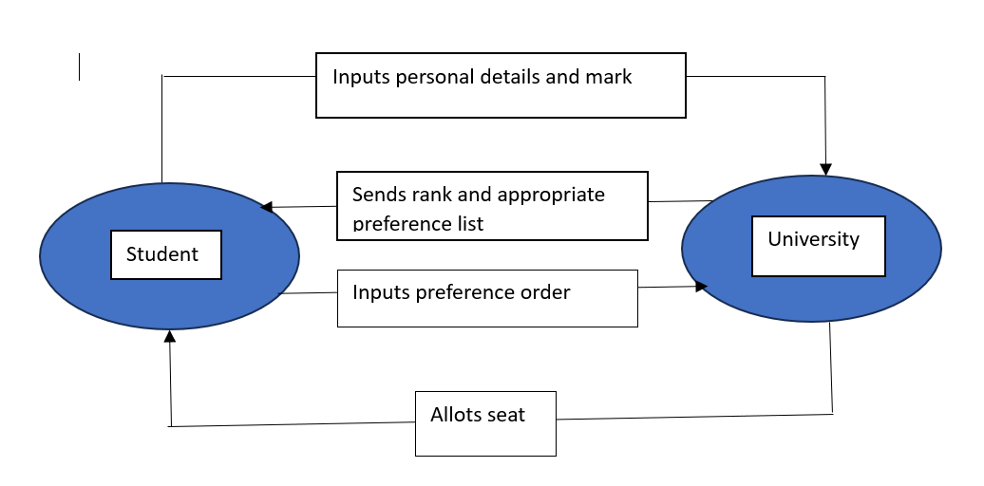

Data Flow Diagram ( Level 2):-

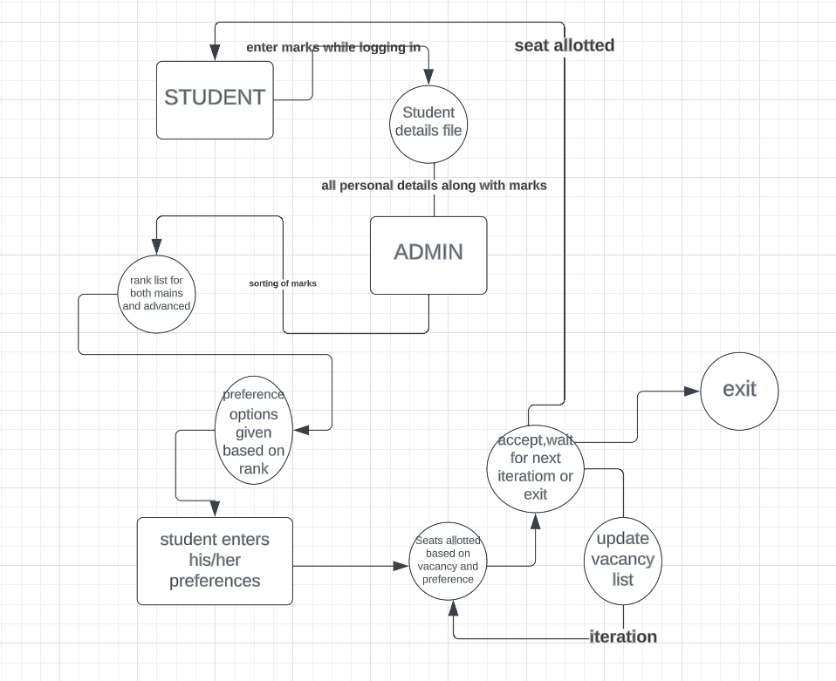

Sequence Digram:-

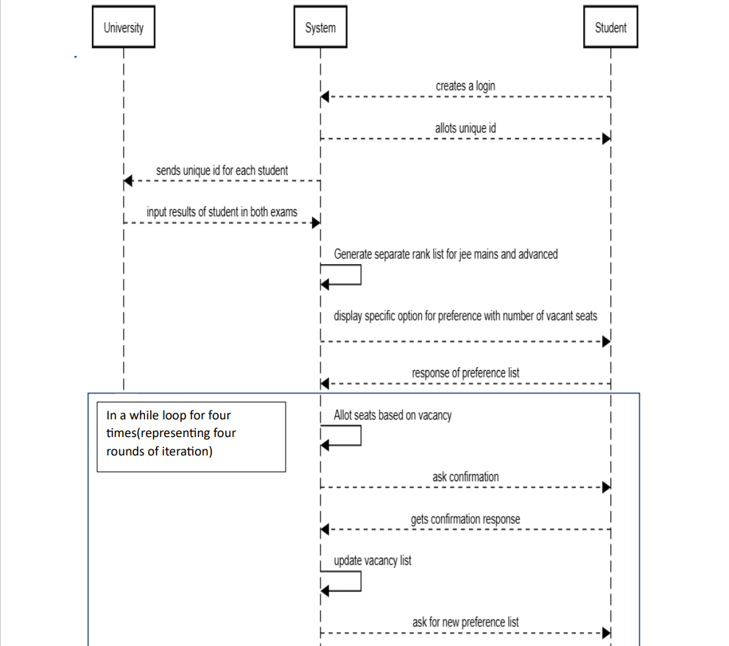

Explanation-:

From the above Sequence Diagram, we can infer the following things:

* Once logged in, the students must enter their Jee main and Jee advanced marks to the system.
* The exam board then takes these marks and generates a rank list.
* 2 rank lists are generated:

Jee main rank list where all students are ranked based on their Jee mains mark only.

Jee adv rank list where all students that are eligible to qualify for the advanced exam are ranked based on their jee advanced marks.

* The university then send their available preference choice list to the user
* The user sends his choice of preference ranked according to his/her choice.
* The seats are then allotted based on their preference in a method explained in detail later.
* The students then have a choice to either choose or wait for a better college they might get.
* Once chosen they can’t change the seat and they have to pay the money and join the college.

Use Case Diagram:-

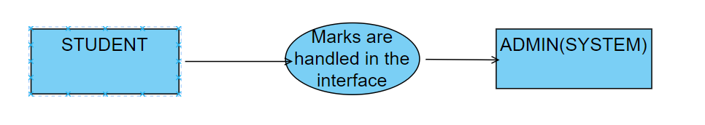

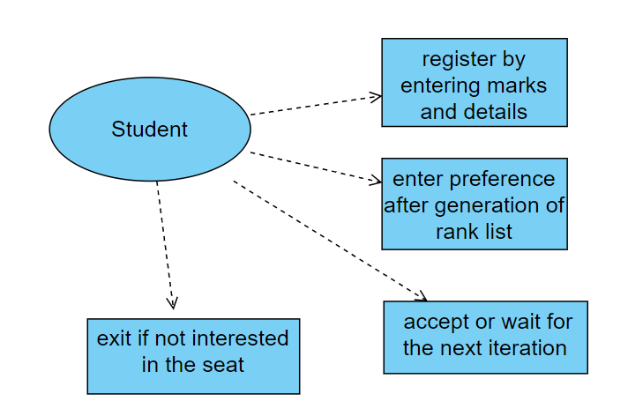

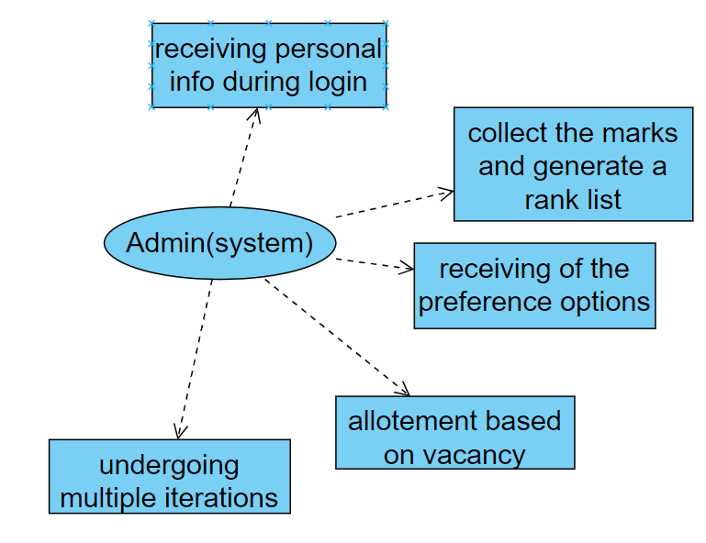

Module 1-: Login/Signup

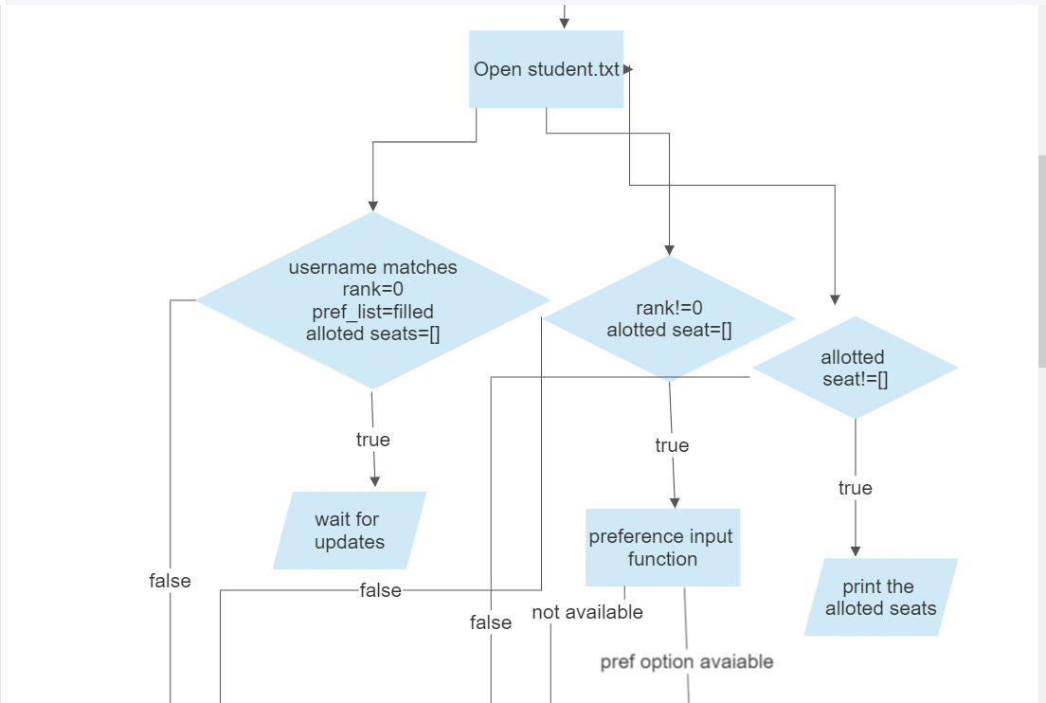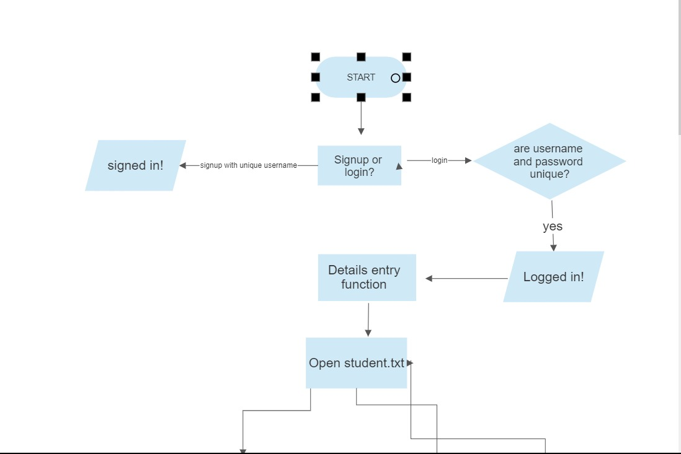

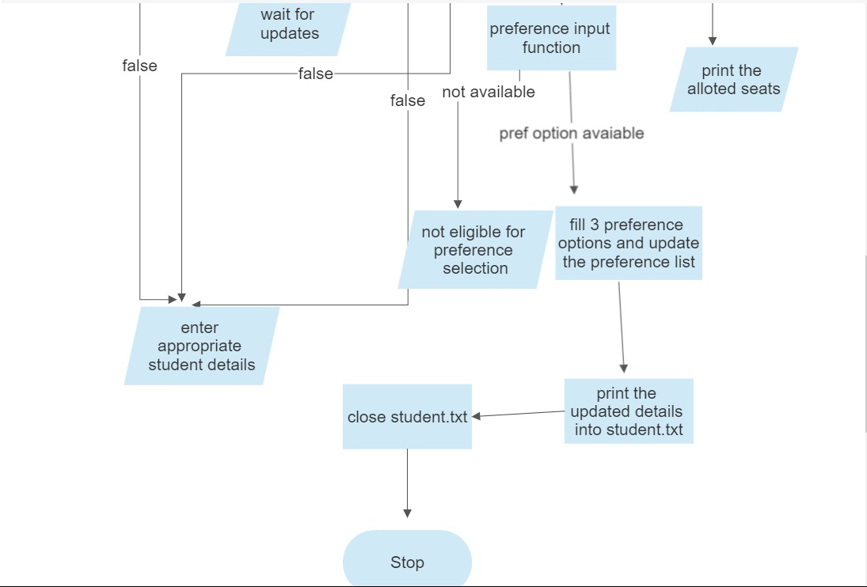

Diagram Explanation-:

* We first give them a choice to either login, signup or exit.
* If they choose, signup:
  + - They can enter their username and password. If the username exists then the signup won’t be accepted.
* If they login, they will be asked to enter their credentials.
* If they satisfy the credentials, then they will be taken to another page to enter their details.
* Here they will enter their details, including their JEE main and advance marks.
* Once several, student details are filled, the rank list is generated.
* They are given choice to choose their preference
* These details are then updated in the Student.txt file, which is printed to the user.
* Based on these preferences and what they are eligible to get,
  + - They are allotted a seat.
    - They are given a choice to wait or skip or choose.
      * + If they wait, then they will be considered for another iteration.
        + If they choose, their seat is confirmed and they are removed from the rank list for further iterations.
        + If they skip, then they are removed from the ranklist.

FUNCTIONS PRESENT IN MODULE:

* login()
* signup()
* studentdetails()

Module 2-: Rank List Generation

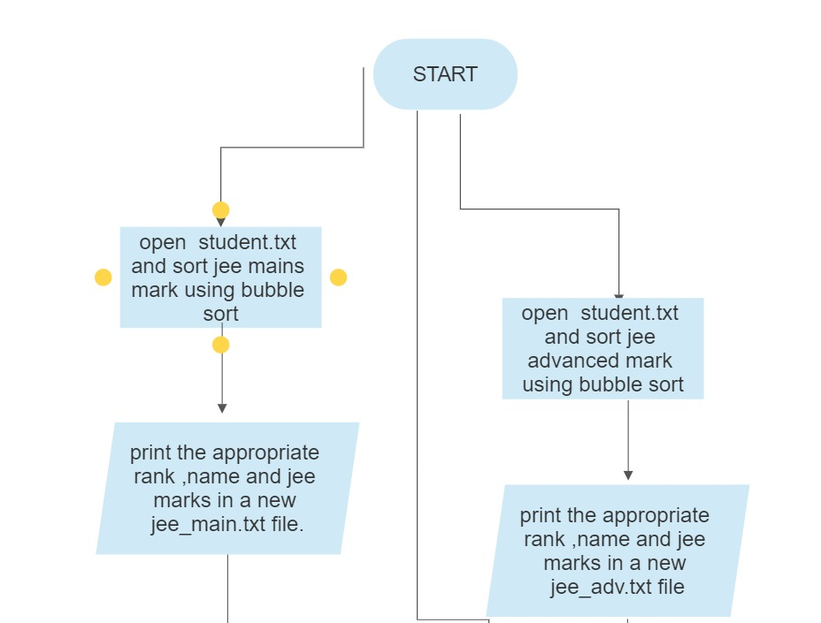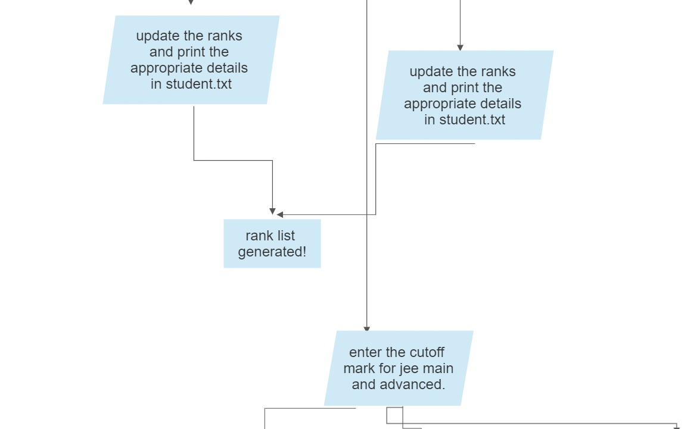

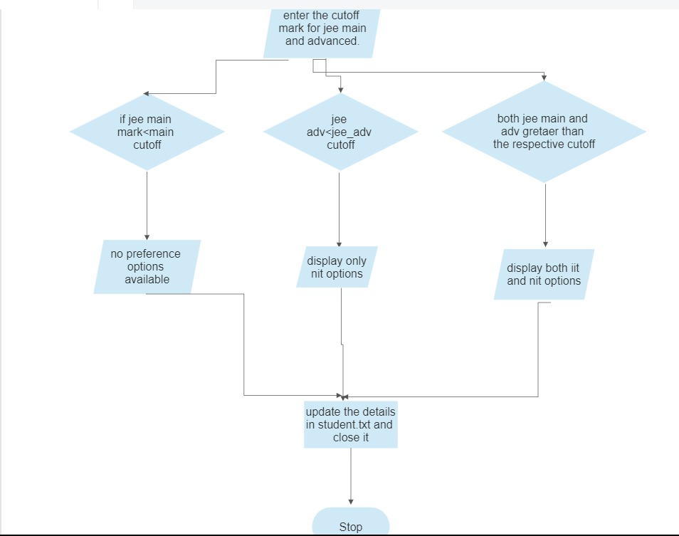

Diagram Explanation-:

* This module is used to generate the rank list.
* In this module, we first get the Jee main marks and the corresponding student’s name from the Student.txt
* The structure got from the file is then sorted using bubble sort.
* This structure is then added to another file called Jee_main.txt.
* We now get the JEE advance mark from student.txt
* This is also sorted the same way we sort the main marks.
* This data is then added to the JEE_adv.txt file.
* The cutoff mark is then obtained as input from the exam board.
  + - If the Jee main mark < cutoff mark, then no preferences are shown to the student
    - If the Jee main mark>cutoff but the advance mark<cutoff, then only NITs are shown to the student as preferences.
    - If the Jee mains and advance marks are> cutoff marks, then all the preferences are shown to the student to choose from.

FUNCTIONS PRESENT IN MODULE:

* Jee_main_sorter()
* Jee_adv_sorter()
* Preference_input()

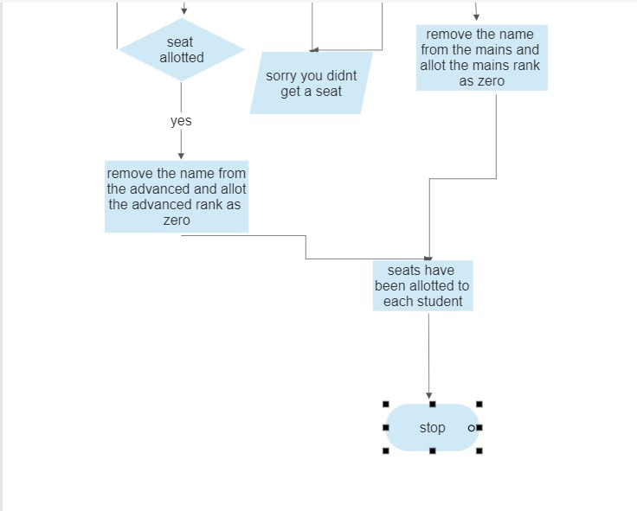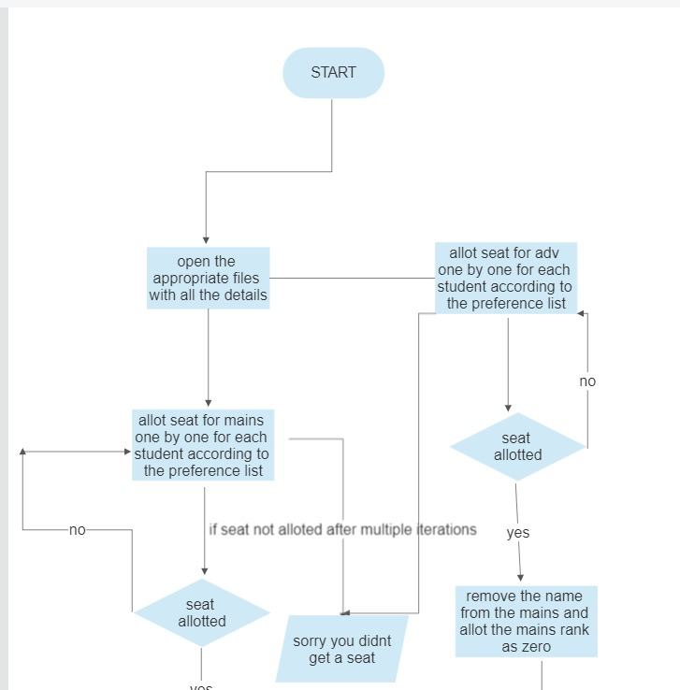Module 3-: Allotting procedure

Diagram Explanation-:

* This is the most important module of all, this is the module that does the allotment of seat to each student.
* We first get the choices from the preferences.txt that the students have given.
* We first allot all the students eligible a seat in NIT college when we first iterate through the NIT rank list.
* Then those who have an IIT college above the NIT college, then we must check for their rank in the Jee advance rank list.
* If they get that seat then, they are allotted a IIT seat and they are removed from the NIT rank list.
* They students are then again allotted a seat in the NIT college based on the updated rank list.
* This process takes place few times until each and every student gets their best choice.
* They are then given the choice to wait or choose or skip.
* If they skip or choose, their name is removed from the rank list and the iteration takes place in the same order (NIT, IIT, NIT).
* If they wait, then their name remains in the rank list to be considered for the next iteration.
* Finally, each student’s seat is added to the file which they can view by logging in.

FUNCTIONS PRESENT IN MODULE:

* Filter_main()
* Filter_adv()
* Allot_main()
* Allot_adv()

IMPLEMENTATION:

Structures used in this Program:-

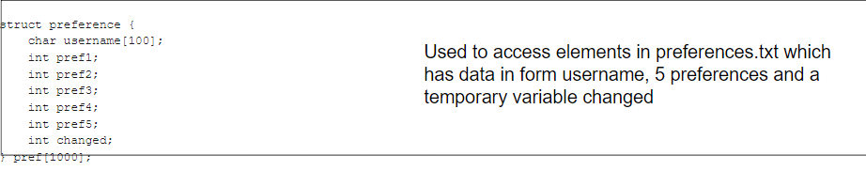

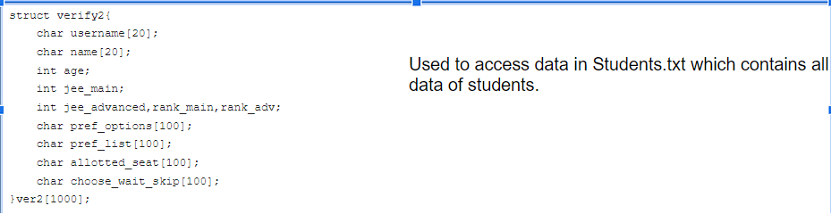

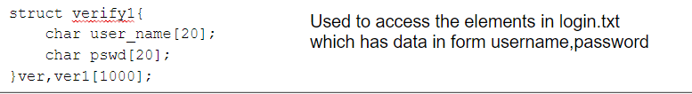

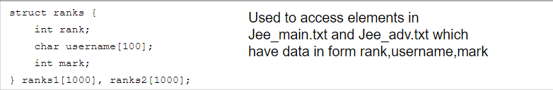

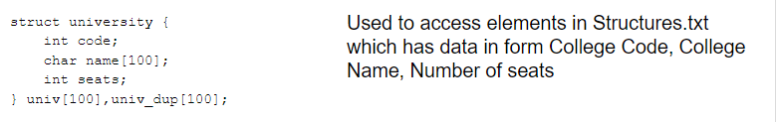

FILES USED:-

|  |  |
| --- | --- |
| File Name | Use |
| Student.txt | Contains all data of each student |
| Stuctures.txt | Contains university code, name and seats |
| Jee_main.txt,Jee_adv.txt | Contains rank list of students and modifies along filtering process used while allocating |
| Preferences.txt | Contains username of student and list of preferences |
| Allot_nit.txt,allot_iit.txt | Temporary files to assist allocating process |
| Login.txt | contains username and password of students used while login |

VALIDATION THROUGH DETAILED TEST CASES:-

In this test case we are able to view how after a student sign up, he enters his details. We are also able to view how usernames are always unique

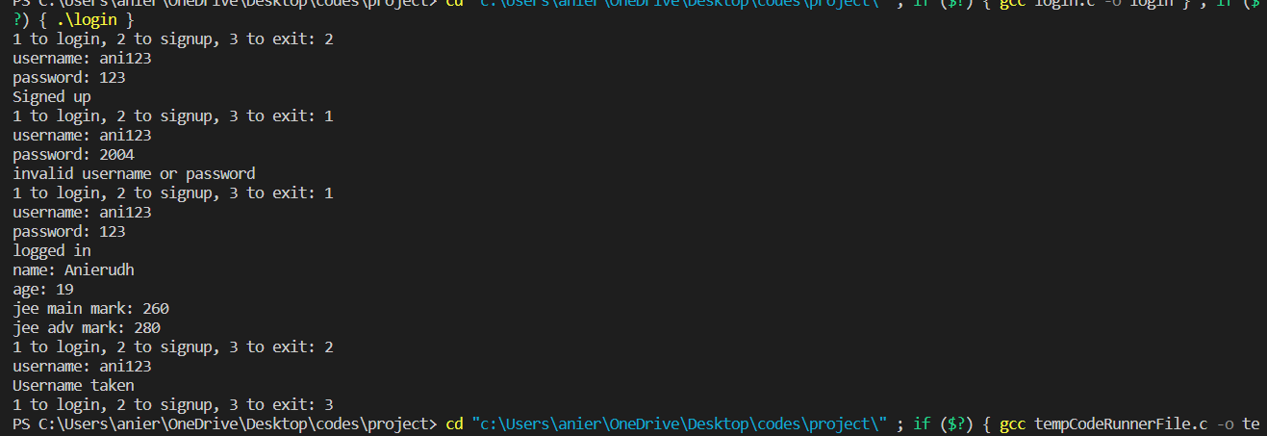

Rank list generation by running rank.c

Input

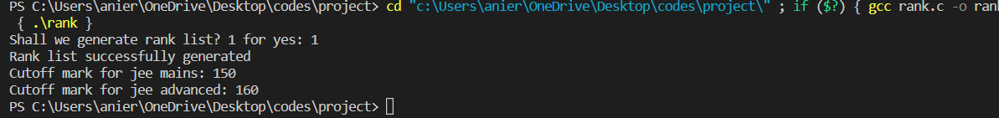

Output

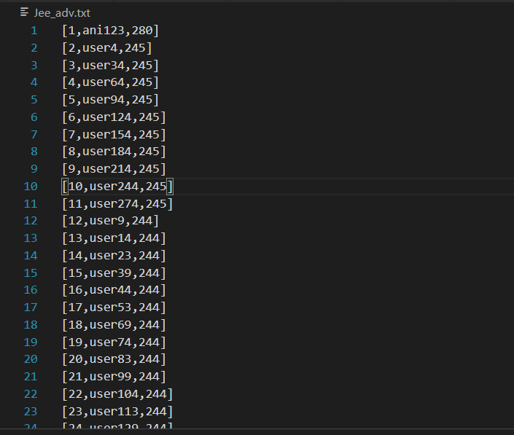 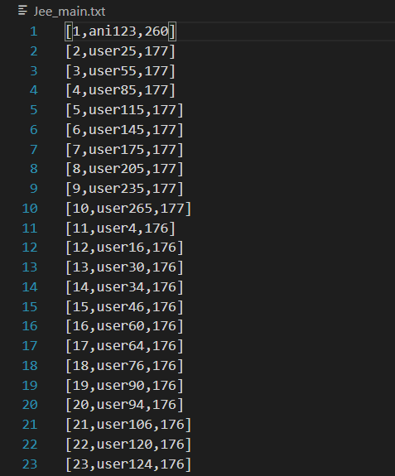

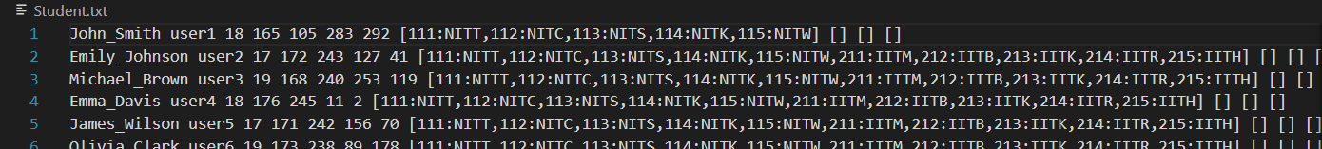

Input preference list:-

We are able to see how student inputs preference options after login. We are also able to view how the status of login keeps updating dynamically.

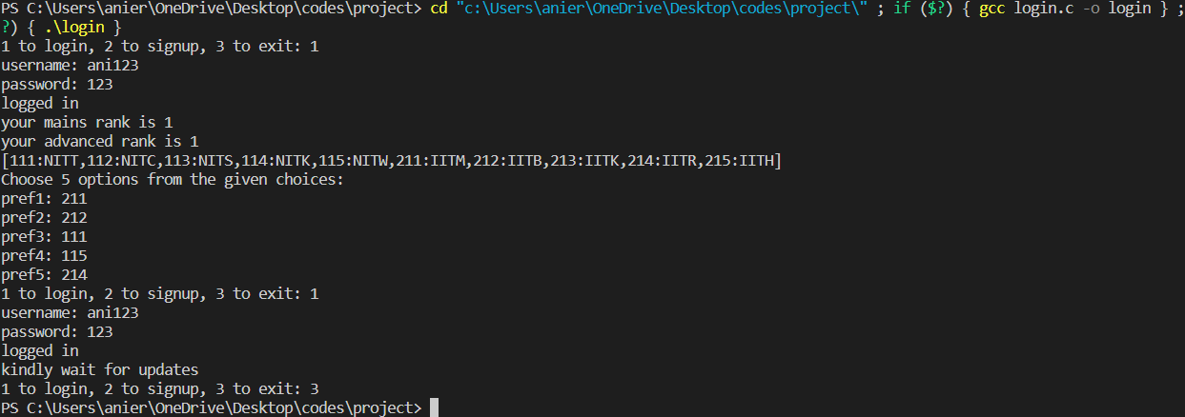

After allotment by running allot.c

We are able to see how the second last column of Students.txt is updates with allotted seats

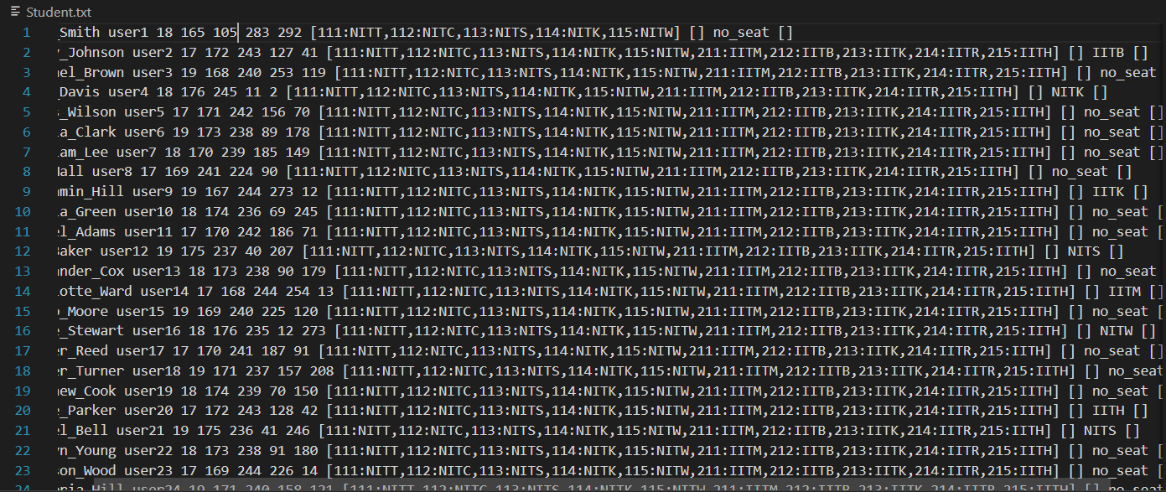

After allotment(first iteration)

We can see how students are able to view their allotted seat in login and also choose/ wait / skip the seat, the result is reflected in number of seats in structures.txt

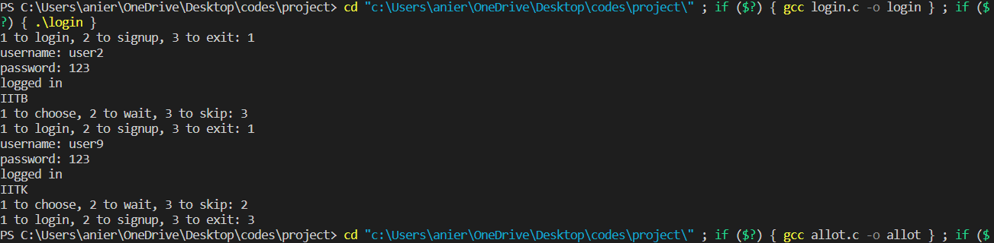

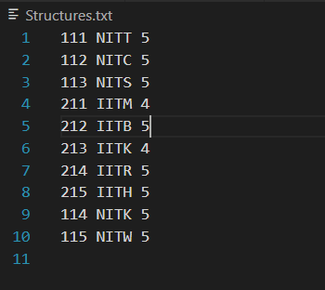

LIMITATIONS:-

In this counselling process, if a student confirms his seat in the first iteration, he may lose the opportunity of getting a better seat in further iterations. As mentioned earlier, our system of counselling is similar to JOSAA counslling, it depends on some luck.

We dont offer change in preference list option. So student has to be very careful with selecting preference list.

We expect all students to choose/wait/skip the allotted seat before moving onto next iteration to avoid allotment of extra seats

SOCIETAL PERSPECTIVE:-

The societal perspective of rank-based seat allotment for examinations can vary depending on different factors and individual viewpoints. Here are some key points that represent different societal perspectives on this topic:

Meritocracy and Fairness: One common viewpoint is that rank-based seat allotment promotes meritocracy and fairness in the admission process. Supporters argue that it rewards students who have performed well academically and ensures that seats are allocated based on their ranking in the exams. This perspective believes that such a system encourages healthy competition and motivates students to work harder.

Equal Opportunity: Another societal perspective is that rank-based seat allotment provides equal opportunities to all students. The process is seen as unbiased because it relies solely on the performance of students in the examinations, irrespective of their background or other factors. This perspective values the principle of equal opportunity and believes that it helps level the playing field for students from different socioeconomic backgrounds.

LEGAL PERSPECTIVE:-

Non-Discrimination and Equal Opportunity: Complies with laws that prohibit discrimination based on factors such as gender, religion, caste, or ethnicity. The seat allocation process is fair, transparent, and provide equal opportunities for all eligible candidates, irrespective of their background or personal characteristics.

Data Privacy and Protection: Handles personal data of applicants in accordance with relevant data privacy and protection laws. This includes obtaining consent for data collection, ensuring data security, and complying with regulations regarding the storage, usage, and sharing of applicant information.

Transparency and Accountability: Accountable for maintaining transparency in the operations. We provide clear information about the seat allocation process, number of available seats.

ENVIRONMENTAL PERSPECTIVE:-

From an environmental perspective, a JOSA (Joint Seat Allocation Authority) seat allotment program can have both positive and negative impacts. Here are some key points to consider:

Reduction in Travel: The JOSA seat allotment program streamlines the admission process for engineering and technical institutions in India. By centralizing the seat allocation, it reduces the need for students and their families to travel extensively to different colleges for counseling and admission. This can potentially lead to a significant reduction in travel-related carbon emissions.

Efficient Resource Utilization: JOSA aims to optimize the allocation of seats based on student preferences and merit. By matching students with their preferred choices and minimizing vacant seats, the program helps ensure efficient utilization of resources within educational institutions. This can contribute to a more sustainable use of infrastructure, energy, and materials.

Learning Outcome:-

* We learnt the basics of C programming and the usage of Data structures in C
* We learnt about the process during allotment procedure for JOSAA admission.
* We learnt the importance of team work to complete the project in time.

References:-

1.<https://josaa.nic.in/>

2.<https://www.telegraphindia.com/edugraph/news/josaa-counselling-2023-round-1-seat-allotment-result-live-on-josaa-nic-in-know-how-to-check-here/cid/1948800>

3.<https://engineering.careers360.com/articles/josaa>

4. https://stackoverflow.com/